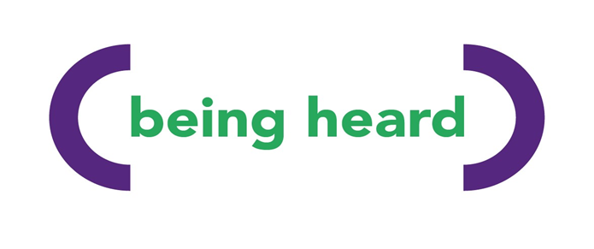

Being Heard: Counselling Service Update
Quarter 1 | April – June 2025

Welcome
As we reflect on the first financial quarter of 2025, we’re proud to share how Being Heard has continued to provide compassionate, person-centred counselling to individuals affected by life-limiting illness within Greater Manchester. This update highlights our activity, insights, and the impact we’re making together.

Referrals at a Glance
Between 1st April and 30th June 2025, we received:
- 66 new referrals into the counselling service
This reflects a steady demand for our service and a strong reputation among partners and referrers across Greater Manchester.
- Referral sources included:
- GPs
- Hospital and community health professionals
- NHS Talking Therapies
- Other charitable organisations
- Self-referrals and family members
- Internal referrals from our Being There Branch Managers

Client Feedback
“I requested the therapy due to me having cancer and my father dying last year. I needed to be able to open up and get help in managing my grief and health problems. The therapist was insightful and very helpful. He made me realise and understand parts of my life that I had taken for granted.”

“I can tell my counsellor anything. She is lovely. I’ve been able to talk about the things that were going on in my mind and how I’ve been feeling. I feel like I am dealing with my situation much better. I have accepted the death of my friend. I am able to mention her name and even go to the places where we used to go together, which I couldn’t do before the counselling. I can’t believe how quickly I got the help and I’m so looking forward to the social groups. I’m very grateful. Thank you for “Being There” for me.”

Service Developments
- We have maintained low waiting times through efficient triaging and flexible delivery (in-person and remote).
- We are currently offering 13 student placements for trainee counsellors
- We have 7 qualified counsellors volunteering at Being Heard
- 6 student counsellors have completed their 100 placement hours at Being Heard in Q1
- Our team participated in peer group supervision twice in Q1
- We secured funding and launched a new “Graduate Scheme” pilot for newly qualified counsellors, encouraging paid work and further experience in the field of counselling.

Looking Ahead to Q2
- Developing the counselling service to ensure sustainability for the future
- Strengthening referral feedback loops with partners
- Strengthening relationships with education providers
- Exploring future funding for the counselling service to continue and expand

Thank You
Thank you for being part of our journey. Whether you’re a referrer, colleague, client, or someone who simply believes in the power of being heard, we’re so grateful for your support.
Together, we help people feel heard, understood, valued, less lonely and isolated.

Rebecca Turner
Counselling Manager – Being Heard
07708 635 183
📧 referrals@beingthere.org.uk
🌐 www.beingthere.org.uk

