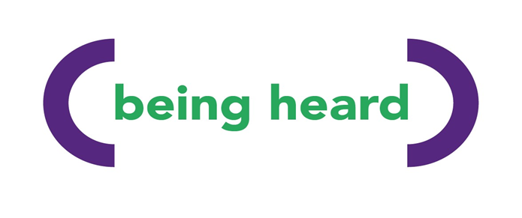

Being Heard: Counselling Service Update
Quarter 2 | July – September 2025

A Message from the Team
As we reach the halfway point of the year, we want to take a moment to reflect on the incredible work taking place across our counselling service. Each quarter brings new challenges and opportunities, and we continue to be inspired by the dedication of our counsellors, students, volunteers, graduates and staff who ensure that every client referred to the Being Heard Counselling Service receives, professional and compassionate person-centred counselling support.
Together, we help people feel heard, understood, valued, less lonely and isolated.

Our Impact This Quarter

Between July and September 2025, our counselling team has made a significant difference in our community:
- 66 new referrals received
- 594 counselling hours delivered
- 22 counsellors and student counsellors providing support
Referral sources included:
- Wellbeing Advisors
- Greater Manchester Mental Health
- Greater Manchester Bereavement Service
- Macmillan Occupational Therapists
- Macmillan Nurses
- Manchester carers centre
- Hospital and community health professionals
- NHS Talking Therapies
- Other charitable organisations
- Self-referrals and family members
- Internal referrals from our Being There Branch Managers
This represents a consistent demand for our service and demonstrates the ongoing need for accessible psychological support for people living with life-limiting illness and their carers and those who are bereaved.

Supporting People Through Connection
Behind every number is a story, individuals and carers who have found space to talk, reflect, and rebuild. Whether through face-to-face sessions, telephone or online support, our service continues to offer a lifeline at some of the most challenging moments in people’s lives.

Focus on Learning and Growth
Our commitment to developing future counsellors remains strong. Student placements continue to play a vital role, offering trainees a safe and supportive environment to learn while expanding our capacity to meet client needs. We also continue to support newly qualified counsellors with our counselling graduate scheme, ensuring they receive a supportive environment to continue gaining invaluable experience in the field in paid employment. Thank you to all our qualified volunteer counsellors who provide their time and dedication to our service. Every hour you give helps to support somebody living with life life-limiting illness, their carers and those who are bereaved.

Looking Ahead
As we move into Quarter 3, we’re focusing on:
- Reviewing client feedback to ensure continuous improvement
- Strengthening partnerships with local healthcare providers, universities and colleges
- Exploring additional wellbeing initiatives to enhance client care

Thank You
A heartfelt thank-you to everyone involved in making our counselling service possible, from counsellors, placement students, graduates, volunteers, staff and referrers. Your dedication ensures that people in our community never face their challenges alone.

Rebecca Turner
Counselling Manager – Being Heard
07708 635 183
📧 referrals@beingthere.org.uk
🌐 www.beingthere.org.uk

